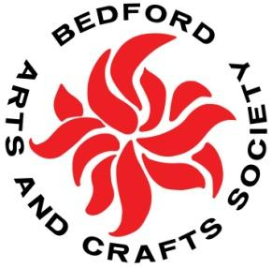 November 2019

Dear BACS friends,

Our holiday luncheon is fast approaching! This year we’ll be doing something different: enjoying a potluck meal and tea. Read below for the details. Also check out the latest news on upcoming Wednesday crafting sessions, as well as art exhibits that are ongoing or coming soon. Happy Thanksgiving!

Sylvia Mallory
slmal@hotmail.com

Holiday Luncheon & Tea December 7
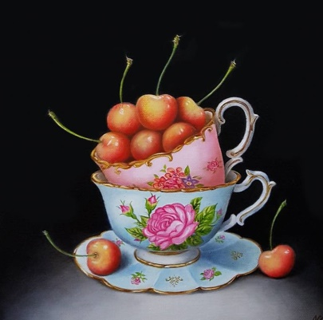
On Saturday, December 7, beginning at noon, we’ll be celebrating the holiday season with a potluck luncheon and tea. All members are welcome. The location will be the First Church of Christ, Congregational, 25 the Great Road, Bedford. Watch for Tanya Lee’s invitation in your e-mail inbox—it will be arriving soon. You can use it to RSVP for the luncheon and to sign up to make a food or drink contribution and/or to help with set-up or clean-up.
We will be having an OPTIONAL gift exchange during the party, featuring consumable items such as packaged food/drink products (coffee, tea, chocolate, cookies, etc.), art/craft supplies, and bath and beauty items. If you wish to participate, please bring a wrapped consumable gift with a maximum price of $10.
In addition, you can visit our “holiday shop” during the festivities, featuring a variety of beautiful crafts made by BACS members over the past year. This will be a great opportunity to purchase a few gifts for the holidays or other giving.
And, as always, we will be collecting optional charitable cash contributions for the Bedford Food Pantry.
For questions, contact Tanya (tanyalee001@gmail.com) or Sylvia (slmal@hotmail.com)

Wednesday Crafting Update
Join BACS members for crafting on Wednesday afternoons, 2:00–4:00 pm, at the Bedford COA. Come to participate or just to chat and relax. The schedule for upcoming weeks is:
- November 13: No-sew fleece blankets for The Linus Project
- November 20: Creating laminated placemats for the holiday party
- November 27: No crafting this week. Happy Thanksgiving!
- December 4: Decoupage boxes using
- paper napkins (bring plain gift boxes if you have them—no store names or other text or designs)
- December 11: Painting
- December 18: TBD
- December 25. No crafting this week. Merry Christmas!
- January 1: No crafting this week. Happy New Year!

For questions and suggestions, e-mail Jane Franklin anytime at crafts@bacsma.org

Free Art Supplies
Laura Wallace is looking to give away some art supplies as follows:
- Jack Richeson Company oil paint, 10 tubes, 7.5 ml each (small)
- Koi watercolor paint, 10 tubes, 12 ml each
If you are interested, contact Laura at laura.b.wallace@gmail.com
Art Change-Over in BACS Member Galleries at the Town Center

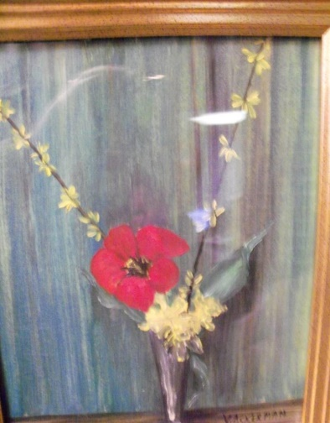
Have you considered exhibiting some of your art in the BACS members’ galleries in the Bedford Town Center’s Flint Room and the COA Computer Room? The opportunity to display your work there is open to all members, and there is no submission fee. We will be changing the artwork on Friday, November 22, from 10:00 am to noon. Bring your new work (up to two pieces) to the Flint Room, and claim any of your art that has been hanging for the past six months. For additional information, e-mail info@bacsma.org

Member Exhibits and News
The current Grace Chapel/Lexington exhibit, “con/TEXT,” opens on November 16 with a
reception from 4:00 to 5:00 pm. A demo of encaustic painting will follow. The show will
run through January 5. Linda Cargiuolo,
Florence Como, Sylvia Mallory, Yvonne Sandell, Doris Smith, and Laura Wallace all
have artwork on view in the show. Visit the chapel’s gallery at 59 Worthen Road to check it out.

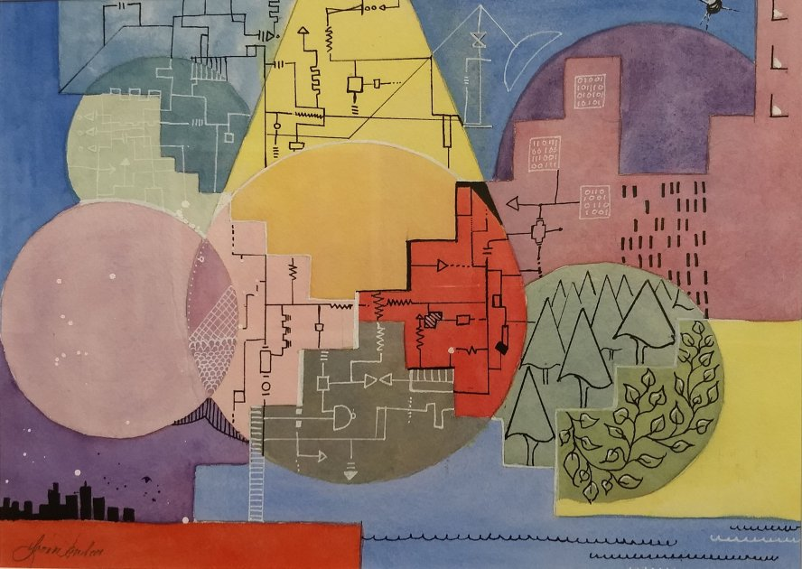
What’s to Understand by Yvonne Sandell
from “con/TEXT”

Paintings by Stephanie Davidson are on exhibit at Bedford’s Short Stop Cafe. If you have questions about displaying your work there or elsewhere, e-mail Judi Babcock at judibabcock@gmail.com
Judi Babcock and Linda Cargiuolo have work on display in the Annual Members’ Exhibition at the Brush Art Gallery and Studios, Lowell. The show runs until December 22. A reception will take place on Saturday, December 7, 2:00–4:00 pm. For details: https://www.thebrush.org/
Biennial Community Art Show Coming to Bedford Library

The Bedford Free Public Library, 7 Mudge Way, has announced the 2019–2020 Biennial Community Art Show, to be held from November 18 through January 8, 2020. The Biennial is a juried exhibit of art by people who live and/or work in the Bedford area. Drop-off will take place in library’s Meeting Room on Friday, November 15, 5:00–6:00 pm, and Saturday, November 16, 11:00 am–noon. Art and craft in all media are eligible. Work must be original, created in the last three years, and not previously shown in the library. 2-D work must be framed and ready for hanging with wire. Entries are limited to two (or series) per person. There is no entry fee. Applications are available in the Events and Exhibits section of the library website: www.bedfordlibrary.net

BACS Members’ Art Show at Bedford Free Public Library

Coming soon is next spring’s BACS members’ show at the Bedford Free Public Library on 7 Mudge Way. The tentative drop-off date is March 11, and members can have others drop off and/or pick up for them. The show will run until May 13. Details will follow in future newsletters.

Art and Crafts About Town
Here’s a selection of nearby shows to visit.
Bedford Free Public Library, 7 Mudge Way, Bedford
See above for dates for the upcoming Biennial Community Art Show.
Concord Art, 37 Lexington Road, Concord
Concord Art’s present show, “Observation and Imagination: Works on Paper,” continues through December 20. For more information visit www.concordart.org
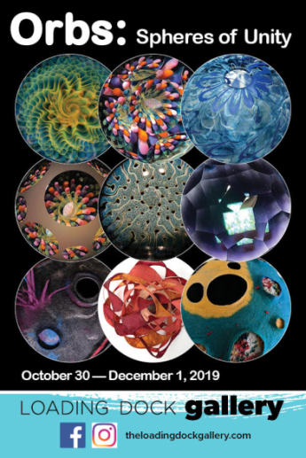
Loading Dock Gallery, Western Avenue Studios, 122 Western Avenue, Lowell
The November show for Lowell’s Loading Dock Gallery showcases “Orbs: Spheres of Unity.” Participating artists explore the unifying principles and significance of orbs, spheres, and circles. The show continues through December 1. For additional info, visit www.theloadingdockgallery.com
Peabody-Essex Museum, 161 Essex St. (for driving directions via GPS, use 1 New Liberty Street), Salem MA
PEM’s exciting new show, “The Nature of Abstraction,” gives a fresh perspective on Hans Hofmann, the artist and teacher widely considered to be a profound influence on American modern art. Through paintings and works on paper from 1930 through the end of Hofmann’s life in 1966, this exhibition traces his journey into abstraction and his contributions to New England’s artistic landscape. More info at: https://www.pem.org/exhibitions/hans-hofmann-the-nature-of-abstraction
E-mail Correction
Please note that Ruth Bragg’s correct e-mail address is ruth.g.bragg@gmail.com
Next Artist Support Group Meeting
The next meeting of the artist support group is scheduled for Monday, November 18, 10:00 am–noon. Please contact Judi Babcock for the location and to RSVP: 781-275-1183; judibabcock@gmail.com
A Thought for November
The ability to simplify means to eliminate the unnecessary so that the necessary may speak. –Hans Hofmann
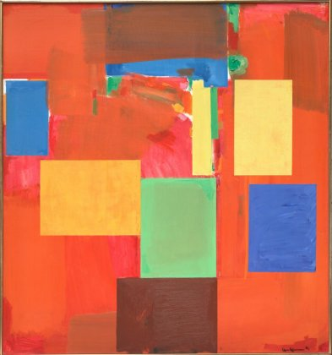
Sanctum Sanctorum (Holy of Holies–Holy Place), 1962, by Hans Hofmann

